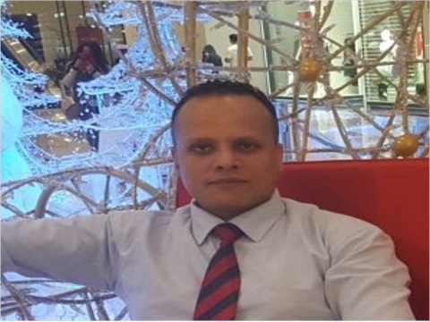

**Hany werdany abd alteaf**

**Birth day 19/02/1979**

**Address : Egypt cario 35st said Arraf al Massara**

**Phone: 00201113997189**

Email: [hanylhh36@gmail.com](mailto:hanylhh36@gmail.com)

**Professional Summary**

have experience 15 years in business retail

I have a wide knowledge in most companies in the Arab world and how to deal with a long experience in the field

of management as I worked as a department manager at MAF Hypermarket for 13 years

**Work Experience**

**goher house ware company egypte -cario ( sales super visor) 02/2005 to 8/2006**

**Responsible for the development of sales to the company by communicating with customers and know their demand**

**Spyniss hyper market (supper visor ) cario egypte 10/2006 TO 7/2007**

**My tasks are to organize the work of lining up, reviewing receipts and making statistics on the date and value of the receipts**

**carrefour hyper market Saudi Arabia supervisor house ware 7/8/2007 to 28/9/2008**

**Carrefour hyper market Bahrain (section manger light house hold)**

**30//8/2008 to 28/9/2019**

**Tasks to ensure the progress of work according to the laws of the company and give guidance to my team to carry**

**out the functional tasks and work orders according to market needs and review the movement of the sale of these**

**goods with control of prices in proportion to the market price in addition to communicate with suppliers**

**Education**

**Bachelor of Arts Department of Philosophy(South Valley University Egypt)**

**My studies in the Department of Philosophy helped me to quickly understand others and easily convince them of my ideas**

**Languages**

**Arabic — Excellent**

**English — very good**

**Additional Skills**

**MCS OFFICE COURSE/ Customer service course/ Accounting Equations Course**